**Smart Solar Window with Adaptive Tracking - IntelliGlass**

Idrees M. Abu Etewy

July-2025

Table of Contents

1. Abstract 3

2. Introduction 4

3. Previous studies and related works 5

4. Literature review 5

5. Problem statement 8

6. System overview 8

7. System design 11

7.1 Microcontroller (ESP32) 11

7.2 Solar Windows Photovoltaic (PV) 12

7.3 Sensors 12

7.3.1 Rain sensors(YL-83 rain sensor) 12

7.3.2 Smoke Sensors (MQ- 2) 13

7.3.3 Light Intensity Sensors 13

7.3.4 Motors (Servo Motor) 14

7.3.5 Chain-driven actuators 14

8. Simulation and results 14

8.1 Methodology 15

8.2 PID Controller 15

8.3 Simulating the panel motion 16

8.4 Overall Solar Tracking System Simulations 17

9. Distributed System Architecture 19

9. Conclusion 20

10. References 21

# Abstract

Installing conventional solar panel systems is challenging due to limited roof space and architectural constraints. In this case, the system proposes a smart solar window with an integrated solar tracking system. As this system would still be used for the primary purpose of providing ventilation while generating electricity, this smart window can be considered as a multi-functional component. The system operates automatically, responding to rain and smoke for safety, or manually for user-controlled ventilation. The system combines sensors, precise actuators, and a PID controller for optimal solar alignment, validated through Simulink simulations. This research adds value to the field by introducing a dynamic, multifunctional solar window system that addresses both architectural and energy challenges, advancing the development of adaptive and energy efficient building technologies.

**Keywords: Smart solar windows, Solar tracking, Renewable energy, Ventilation, Distributed Control system, IOT, SCADA, MQTT, Machine Learning.**

# 2. Introduction

With the rapid growth of global demand for renewable energy, it is essential to have alternative solutions that can integrate smoothly into urban environments. Solar energy has a significant potential to minimize reliance on conventional energy sources. However, there are certain challenges in adopting conventional solar panels in urban areas such as rooftop space limitations, architectural confine and structural restrictions. Because of these challenges, it is difficult to acquire solar energy widely in buildings, where feasible energy solutions are crucially needed. The smart solar window system with integrated solar tracking has been developed as a new perspective to absorb ultraviolet and infrared light through windows and convert them into electricity while tackling the above-mentioned challenges[6]. The primary purpose of designing windows is to provide ventilation and natural lighting for a building, but they are rarely considered for electricity generation. But this smart window system is a dual-functional window design that utilizes solar panels with the existing window structure by integrating photovoltaic (PV) technology into the window surface to enable generating electricity without compromising ventilation. Hence, it fulfills the requirement of a window and enables solar energy adoption where rooftops might not be able to support the use of solar panels.

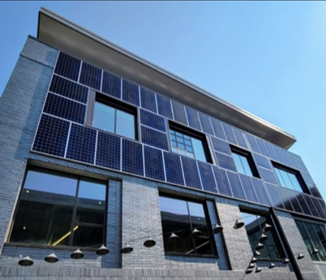

Figure 1. Solar window.

What makes this system unique is the composition of the solar tracking mechanism, which allows for a window to be adjusted at different angles throughout the day, responding to real-time changes in sunlight. This mechanism enhances the energy efficiency. This system allows users to control window openings manually or automatically to their required levels to have desired ventilation. Once the window opens for the desired level, the solar tracking mechanism activates by detecting sunlight through sensors and aligns the window for maximum efficiency. In case of excessive smoke, smoke detectors deploy the solar window to fully open, and in case of rain, rain sensors deploy the window to close automatically. The primary benefit of this system is improving energy efficiency while optimizing space. This allows energy production to be increased while still providing the primary purpose of ventilation.

# 3. Previous studies and related works

Numerous advancements have been made in the integration of photovoltaic systems with architectural components, particularly transparent solar windows. According to Liu et al. [1], the development of thin-film transparent PVs using organic and polymer-based materials has opened the door for seamless energy harvesting in modern buildings. Husain et al. [7] reviewed the state-of-the-art technologies for integrating photovoltaics into transparent substrates, emphasizing the balance between transparency, energy efficiency, and aesthetics.

Tracking mechanisms have also evolved, with single-axis and dual-axis configurations demonstrating significant improvements in energy yield [2], [3]. Baouche et al. [4] demonstrated through simulation that active tracking systems increase solar capture efficiency compared to fixed panels. More recently, Yang and Zhou [8] proposed smart window systems embedded with environmental sensors for adaptive behavior, showcasing a growing trend toward integrated automation and smart control.

However, most existing systems either focus solely on energy capture or environmental response. The integration of safety systems, environmental sensing, and energy tracking in a unified, multifunctional window solution remains underexplored, which is addressed by the current system.

# 4. Literature review

The evolution of solar energy system has indicated substantial improvements with solar windows and tracking systems. This system enables the optimization of electricity generation with the use of transparent photovoltaic technologies combined with a tracking mechanism. The concept of integrating solar technology into windows dates back to the mid-20th century. The early version of solar windows was static systems with embedded opaque solar cells into glass structures. However, they compromised transparency and aesthetic appeal while enabling electricity generation. With the advancement of thin film technology, partially transparent solar windows were created. with the use of silicon and cadmium telluride, it was able to design semi-transparent windows with the ability to generate electricity. In the 21st century, the focus moved towards visibly transparent PVs that absorb non-visible wavelengths of light. However, the energy generation eff**Transparent Thin Film PV**iciency of those systems depended on the positioning of the window and the angle at which the sunlight hits the window. Due to their inability to optimize energy capture from varying sun positions, those systems had limited efficiency. With the incorporation of tracking systems, the efficiency of solar windows was increased. in earlier mechanical rotation and motors were used as tracking mechanisms to have alignment of the PV cells with the sun’s movement. With the advancement of technology, the orientation of the window is dynamically adjusted with the use of sensors like light-dependent resistors and solar intensity resistors. The use of these sensors ensures energy efficiency.

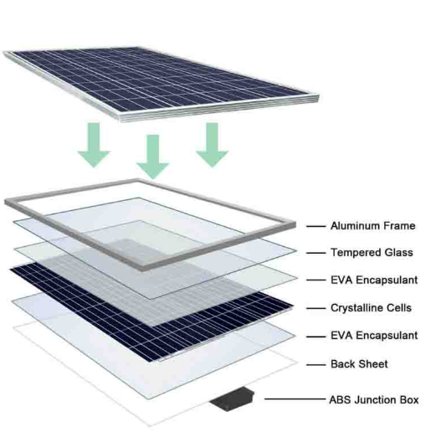

Figure 2. Transparent Photovoltaic system.

There are two main configurations of solar windows as Transparent Photovoltaic ( TPV) systems and concentrator technologies. Each category has different benefits and challenges. Transparent photovoltaic systems enable the generation of electricity directly on the window surface. These TPV systems can be further divided as spatially segmented PV, Semi-Transparent Thin Film PV, and Transparent Thin Film PV.

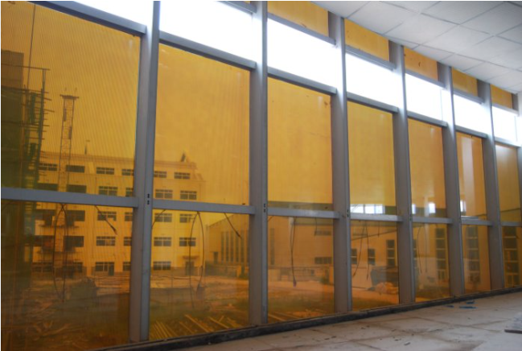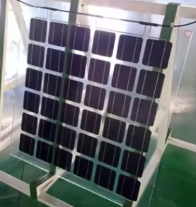

Figure 3. Semi-transparent Thin Film PV. Figure 4. Transparent Thin Film PV.

Spatially Segmented PV is a Transparent photovoltaic system that employs opaque solar cells implanted within a transparent surface. These systems compromise aesthetic appeal due to the lack of transparency while providing energy generation. These systems are primarily used in industrial applications.[1] Semi-transparent thin film PVs are Non-wavelength Selective Thin Film Photovoltaic systems that use materials like amorphous silicon to absorb ultraviolet (UV) and infrared (IR) light while allowing partial light transmission.[1] As these systems provide reduced solar gain without compromising visibility, they are commonly used in partially tinted windows in residential and commercial settings. Transparent Thin Film PVs are wavelength-selective photovoltaic systems designed to transmit visible light while absorbing UV and IR light. These systems use materials like polymers, nanotubes, and organic molecules to have high transparency.[1]

The tracking system increases the efficiency of solar windows by aligning the window surface with sun’s movements. These systems can be categorized as Single-Axis Tracking systems, Dual-Axis Tracking systems and Three-Axis Tracking systems based on the axis.

Single-Axis Tracking Systems offer one degree of freedom, making them simpler and more cost-effective. They are commonly used in large-scale systems and come in subtypes such as horizontal, vertical, tilted, and polar-aligned trackers. Horizontal trackers rotate parallel to the ground, vertical trackers rotate perpendicularly, tilted trackers operate on an inclined axis, and polar-aligned trackers follow Earth’s rotational axis [2].

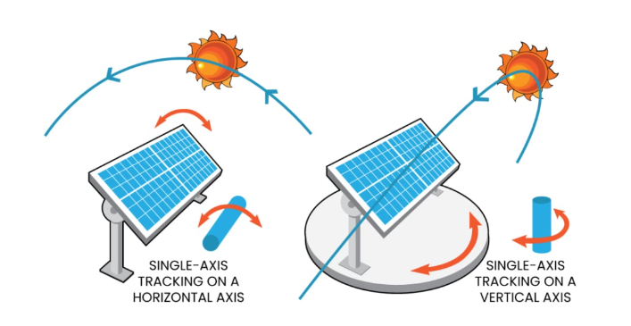

Figure 5. Single Axis Tracking

Dual-Axis Tracking Systems provide two degrees of freedom, enabling panels to move in both tilt (elevation) and azimuth (horizontal) directions. The most common configurations include Tip-Tilt and Azimuth-Altitude types. Although dual-axis systems are more complex and expensive, their ability to maximize energy capture throughout the day and year [3] makes them highly effective in high-efficiency applications [2].

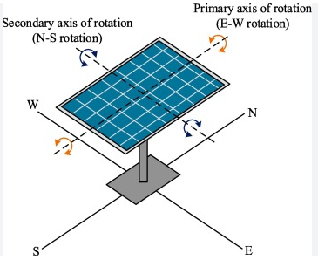

Figure 6. Dual Axis Tracking

# 5. Problem statement

Traditional windows provide light and ventilation but fail to harness their full potential for renewable energy generation. Though solar-integrated windows have been explored, most designs are static and cannot track the sun, reducing energy efficiency. They also often compromise transparency and aesthetics, making them less attractive in building applications, despite increasing demand for sustainable solutions.

Conventional windows lack adaptability to weather or emergencies—they don’t automatically close during rain or open during smoke. Manual operation is still the norm, which limits efficiency, and most systems don’t support scheduled operation for ventilation or shading control throughout the day.

To address these limitations, this research proposes a smart solar window system that integrates sun tracking to optimize energy output while maintaining transparency and aesthetic appeal. It responds automatically to environmental triggers and allows user-controlled settings and scheduling. By combining solar tracking with smart features, the system improves energy harvesting, safety, and usability, offering a modern solution for sustainable architecture.

# 6. System overview

The smart solar window system is an innovative solution designed to enhance energy efficiency and ensure safety by automating window operations and optimizing solar energy capture. It integrates advanced sensors, precise actuators, and solar tracking mechanisms to respond adaptively to environmental changes. The Smart Solar Tracking Window System is implemented using combining the following components. A Chain Driven Actuator for opening and closing, a Rotary Motor for rotating the window, Rain Sensors to detect rainfall, Smoke Sensors to detect smoke, Light Dependent Resistors (LDRs) to continuously monitor sunlight intensity, and a Microcontroller to process inputs from the sensors and control the actuators and motor. Additionally, an Energy Storage System may be included to store solar energy. These components work together to enhance energy efficiency and prioritize safety in an automated system. The block diagram of the system is given in Figure 7.

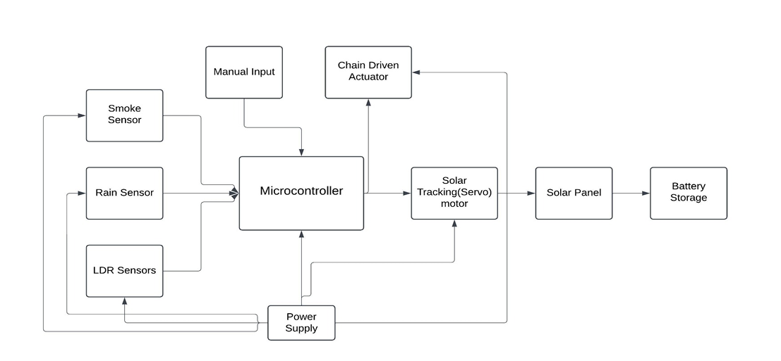

Figure 7. System Block Diagram

**Workflow**: The system begins by monitoring the smoke and rain conditions of the environment using the smoke and rain sensors. First, the system checks the smoke sensor output to ensure that there’s no fire threat. If the smoke sensor detects smoke in the environment, it signals the microcontroller to immediately open the windows to its maximum position. This ensures that the safety mechanisms are always prioritized. If the smoke sensor detects no smoke, then the system checks the rain sensor to check whether it’s raining. If there is rain while the window is open, the system checks whether the sun tracking motor is in its original position to ensure the window panel is correctly positioned before it is closed using the chain-driven actuator. When no safety triggers are active (smoke or rain), the system proceeds to the pre-safety-action state. The window can be opened by the user to a preferred amount in order to get the required ventilation and light. Once the window is opened and no safety triggers are active, it starts the sun tracking process and starts generating power. The sun tracking process involves comparing the light intensities measured by the two LDRs.

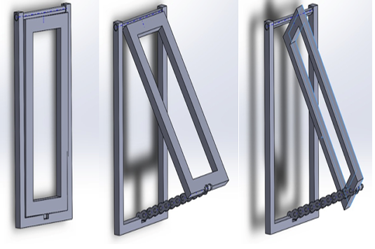

Figure 8. Solid Works Diagrams showing Closed, Opened and Solar Tracking positions of the Window

**If V1 − V2 > Vth2** (If the voltage across the left LDR exceeds the voltage across the right LDR by a value greater than the specified threshold), the motor moves right. If **V2 − V1 > Vth2** (If the voltage across the right LDR exceeds the voltage across the left LDR by a value greater than the specified threshold), the motor moves left. This threshold defines the minimum difference in light intensity required to activate the motor, preventing constant minor adjustments and allowing the system to maintain a stable position unless a significant realignment is necessary. This approach not only enhances stability but also ensures energy-efficient operation. If the voltage difference between the LDRs is below the specified threshold, the sun-tracking motor halts operation. After each sun-tracking movement, once the sun-tracking motor stops, or after the window is closed due to rain, the system restarts by rechecking the smoke sensor output to ensure proper ventilation and safety. The window panel can be manually closed by the user at any preferred time or scheduled to close automatically at a specific time. Solar energy harvested by the system is first converted by solar panels into DC electricity, then converted to AC using an inverter, and either stored in batteries or sent to the main grid. The system ensures that energy is used efficiently to power the window’s operations or any other connected devices. The flowchart given in Figure 9 illustrates the control algorithm used for the Smart Solar Window System with Integrated Solar Tracking .

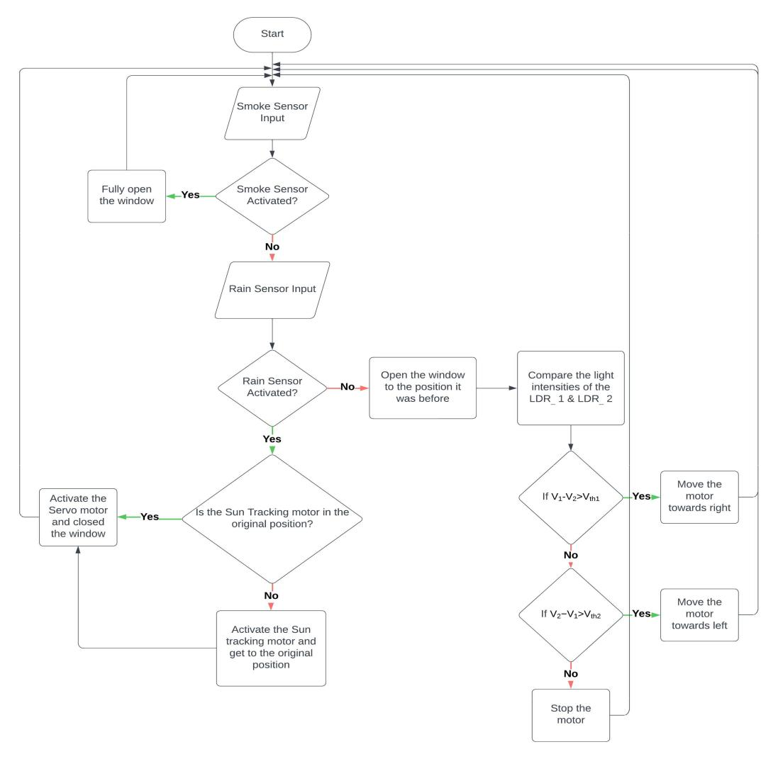

Figure 9. Control Algorithm

# 7. System design

The smart solar window system integrates various components, each playing a critical role in the practical implementation of a functional prototype.

## 7.1 Microcontroller (ESP32)

The ESP32 microcontroller is a powerful, dual-core processor well-suited for smart solar tracking systems that require high efficiency and wireless connectivity. It collects real-time data from various sensors, processes light intensity differences, and adjusts the solar panel’s position using intelligent algorithms such as PID or ML-based models. Its integrated Wi-Fi and Bluetooth capabilities enable seamless remote monitoring, mobile app control, and cloud-based automation, eliminating the need for additional communication modules.

Compared to traditional microcontrollers like the Arduino Uno, the ESP32 offers significantly higher computational power, memory, and I/O capabilities. These advantages make it an ideal choice for implementing advanced features such as machine learning-based prediction, OTA updates, and integration with IoT platforms like Blynk or Firebase. The ESP32 enhances system performance and scalability, making it highly suitable for next-generation adaptive energy solutions in smart building applications.

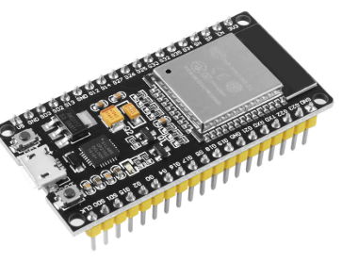

Fig. 10. ESP32 Dev Module

## 7.2 Solar Windows Photovoltaic (PV)

Solar windows play a critical role in solar tracking systems by combining energy generation with natural lighting. Integrated with transparent or semi-transparent solar cells, they capture sunlight to produce electricity while allowing light to pass through, ensuring efficient energy utilization without compromising visibility.

## 7.3 Sensors

### 7.3.1 Rain sensors(YL-83 rain sensor)

The YL-83 rain sensor is essential in smart window systems, enabling automatic responses to rain by detecting resistance changes when water bridges its conductive tracks. This functionality allows the smart window to close or adjust based on rainfall[10].

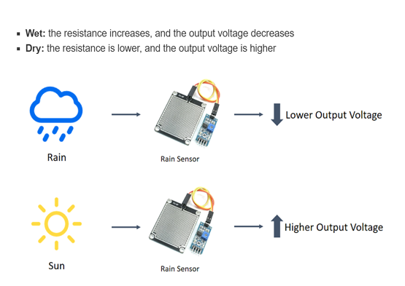

Figure 11. Rain Sensor

### 7.3.2 Smoke Sensors (MQ- 2)

The MQ-2 smoke sensor plays a crucial role in smart windows by detecting smoke and flammable gases through changes in electrical conductivity. Its versatility makes it ideal for fire and smoke detection in residential or commercial environments. By integrating the MQ-2 into a smart window system, it can trigger automated responses such as ventilation or window opening, ensuring safety and improving air quality when smoke is detected. This sensor’s reliability and broad detection range make it an essential component for enhancing the functionality and safety of smart windows [11].

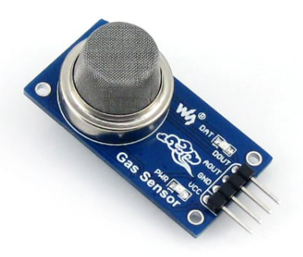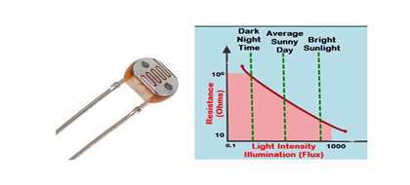

Figure 12. MQ-2 Smoke Sensor Figure 13. LDR and Variation of Resistance with Light

### 7.3.3 Light Intensity Sensors

A photoresistor, also referred to as a Light-Dependent Resistor (LDR) or photoconductive cell, is a resistor whose resistance varies in response to the intensity of light it receives. Typically, the resistance of an LDR decreases as the light intensity increases. In the proposed system, the microcontroller processes the light levels detected by the LDR sensors. Based on this data, the microcontroller determines the optimal direction and adjusts the position of the solar panel to align with the highest intensity light, ensuring maximum energy capture and efficiency.

### 7.3.4 Motors (Servo Motor)

Servo motors are essential in solar tracking systems, providing precise angular control and dynamic positioning to align solar panels with the sun for optimal energy capture. They receive control signals from the microcontroller, which processes data from light intensity sensors to determine the best panel orientation. Servo motors are particularly effective due to their high torque at varying speeds, allowing the panels to adjust to the sun’s movement even under load or environmental resistance. Their built-in feedback systems enable real-time corrections, ensuring continuous and accurate alignment throughout the day for maximum energy efficiency.

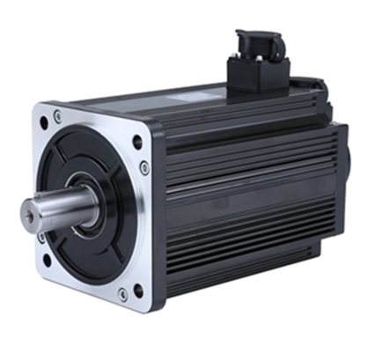

Figure 14. Brushless DC (BLDC) Servo Motor

### 7.3.5 Chain-driven actuators

Chain-driven actuators provide precise control over the window’s angle and position. These actuators use a chain mechanism to adjust the window, allowing for smooth and reliable operation. Chain-driven actuators are robust, capable of handling heavy loads, and offer fine control over window movement, making them ideal for applications where precise positioning is required for both ventilation and energy optimization in smart window systems

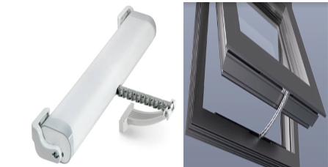

Fig. 15. Mingardi MICRO-S Chain actuator and its practical implementation

# 8. Simulation and results

Solar Tracking feature of the solar window. The glass of the panel of the window is made up of Transparent Photovoltaic Materials, which produce solar power during the day. In the design of the solar window, the system incorporates a solar tracking feature that activates when the user opens the window to a predetermined angle. The purpose of the solar tracking feature is to maximize the production of solar power during the daytime. In order to make sure that the user gets the required amount of ventilation and light through the window, as well as to improve the efficiency of the solar window more than a normal solar window, A single-axis solar tracking system has been implemented. A Dual Axis Solar Tracking System can also be used; however, the problem is that it may limit ventilation and restrict airflow through the window while adjusting its orientation to follow the direction of the sun.

## 8.1 Methodology

One-axis sun tracking systems use only two sensors, which in this case, two LDRs have been used for the practical implementation of the model. The main idea is to read the value of light density from **LDR 1** and **LDR 2**, then take the difference between the two values. Depending on the difference between the two values, the system will decide and send commands to the motor and change its angle in order to make the difference equal to zero**. (LDR 1-LDR 2=0),** Then the light intensity on both LDRs will be the same. This process, which enables the system to align optimally with the sun, is illustrated in the block diagram provided in Figure 16

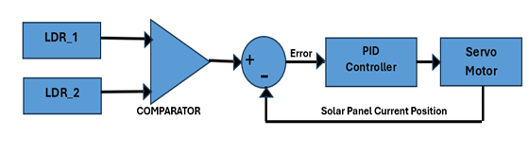

Fig. 16. Block Diagram of the Solar Tracking Feature.

## 8.2 PID Controller

A PID controller (Proportional-Integral-Derivative controller) is a widely used control system mechanism designed to maintain a desired setpoint by minimizing the error between the setpoint and the actual process value.

rapid response. Let us examine each component of the PID controller. The Proportional controller (P) offers a simple design with a quick response time, but is unable to fully eliminate the error signal. The Integral controller (I) is effective for systems with slow-changing dynamics and can correct the error signal, although it is less suited for rapidly changing systems. The Derivative controller (D), while unable to correct the error signal and prone to amplifying noise, is ideal for fast-changing systems that require a rapid response.In the context of solar tracking, a PI controller is sufficient as the sun’s movement across the sky is slow and predictable. The proportional component (P) ensures a quick response to any misalignment, while the integral component (I) gradually eliminates any steady-state error, ensuring precise alignment over time. Since the sun’s position does not change rapidly, the derivative component (D), which is designed to handle fast-changing dynamics, is not necessary. This simplifies the control system while maintaining efficient and accurate tracking performance. The PI controller used in this system was tuned with a proportional gain of 240 and an integral gain of 180. These parameters were selected to achieve an optimal balance between response speed and steady-state accuracy. The chosen values ensure that the system can quickly reduce misalignment while effectively eliminating any residual error, enabling precise and stable solar tracking performance.

The PI controller used in this system was tuned with a proportional gain of 240 and an integral gain of 180. These parameters were selected to achieve an optimal balance between response speed and steady-state accuracy. The chosen values ensure that the system can quickly reduce misalignment while effectively eliminating any residual error, enabling precise and stable solar tracking performance.

## 8.3 Simulating the panel motion

The simulation was conducted to verify the correctness of the panel’s motion in response to the torque input from the motor. By using the panel’s equation of motion given in Figure 17 and applying constant torque values, the simulation focused on ensuring that the panel’s rotation aligns with the expected direction based on the sign of the input torque [5].

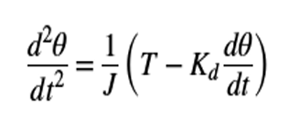

Figure 17. Panel equation of motion

With a constant torque, the panel starts turning and then settles to rotating at a fixed rate. When the sign of the constant torque is negative, the panel rotates in the opposite direction. This can be seen as the angle of rotation increases and the velocity is slowly reaching a constant value.

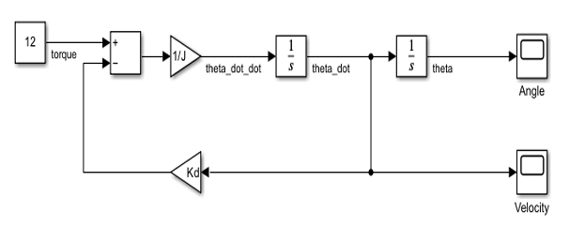

Figure 18. Simulink Model for the Panel Equation

Simulations were done using the Simulink model provided in Figure 18 [5], and the variations of the Angle and the Velocity of the Panel were taken as observations.

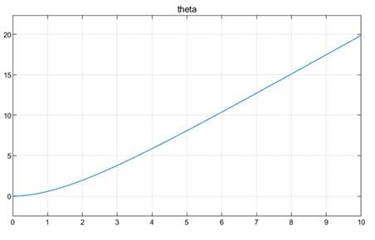

Figure. 19. Variation of Panel Angle with time

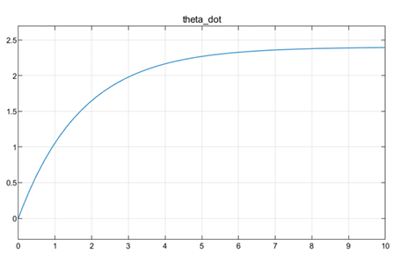

Fig. 20. Variation of Panel Velocity with time

## 8.4 Overall Solar Tracking System Simulations

In the simulation, instead of using the two LDRs and a comparator to detect the light intensity difference, a unit step function has been used to simulate a sudden change in the sun’s position. This unit step function represents the difference in light intensity that would typically be detected by the LDRs as the sun moves. Figure 21 shows how the panel position, along with the sun’s position, maximizes the power generation.

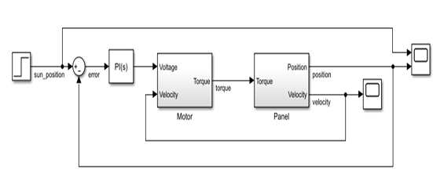

Figure 21. Simulink model for Single Axis Solar Tracking Simulation

By using this simplification, the simulation focuses on evaluating the system’s response to a discrete shift in light intensity, allowing the control mechanism to adjust the solar panel’s position accordingly.

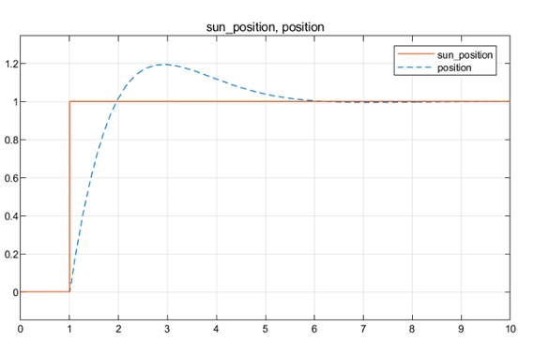

Figure 22. Alignment of the Panel Position with the Sun’s Movement

# 9. Distributed System Architecture

The nodes communicate wirelessly over Wi-Fi using the MQTT protocol, which enables lightweight, real-time data exchange. A central broker manages communication between nodes and connects them to a cloud-based platform for monitoring and control. Each window publishes its sensor readings and operational state to the broker and receives commands or configuration updates in return.

The system is integrated with platforms such as Blynk Cloud or Firebase, which serve as remote interfaces for monitoring and manual override. These platforms offer real-time dashboards accessible via mobile or web, displaying status indicators, energy output, and environmental alerts.

This architecture supports both local and centralized decision-making. Windows can react instantly to safety events, such as rain or smoke, while the cloud platform manages scheduling, performance analysis, and coordination between multiple units. The distributed structure also enables future expansion into building-wide energy and ventilation management.

This design aligns with SCADA and IoT-based control standards, supporting modular deployment and scalable communication between intelligent window units in a coordinated system.

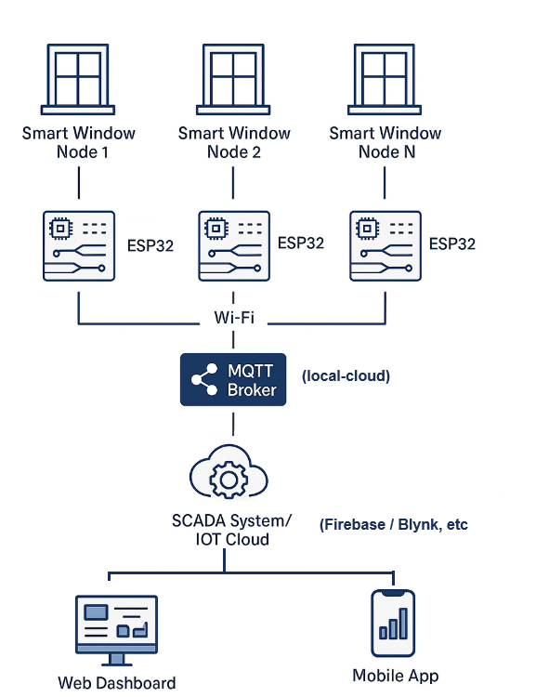

Figure 23. Overview of the distributed system architecture for IntelliGlass

# 9. Conclusion

The Smart Solar Window System presents a novel approach to enhancing energy efficiency and safety through automated window operations integrated with solar energy optimization. By utilizing advanced sensors, precise actuators, and solar tracking mechanisms, the system ensures adaptive responses to environmental changes, prioritizing safety during smoke or rain events while maximizing sunlight capture for energy harvesting. The integration of an energy storage system further supports sustainable energy utilization, enabling the system to operate efficiently and autonomously.

Despite its promising capabilities, the system has certain limitations. The reliance on environmental conditions, such as consistent sunlight for optimal solar energy capture, and potential delays in response due to sensor or actuator constraints, may affect performance in adverse conditions. Additionally, the cost and complexity of implementing and maintaining the system could pose challenges for large-scale adoption.

Future developments may involve the integration of a dual-axis tracking mechanism to further optimize solar alignment while considering indoor ventilation needs. By incorporating user-defined preferences and real-time environmental data, the system can intelligently determine optimal window orientations to balance both ventilation and energy generation. Such improvements are expected to increase the system’s adaptability, efficiency, and applicability in modern sustainable architecture.

# 10. References

1. T. Liu et al., “Solution-Processed Thin Film Transparent Photovoltaics: Present Challenges and Future Development,” Nano-Micro Letters, vol. 17, no. 1, Oct. 2024, doi: https://doi.org/10.1007/s40820-024-01547-6.
2. A.Priyam, ”Solar Tracking Systems - A Review”, Department of Mechanical Engineering, MPSTME, NMIMS University, Mumbai- 400 056, India.
3. A. Pandit, A. KC, K. Poudel, and P. Sah, “DUAL AXIS SOLAR TRACKER SYSTEM,” Kushal Poudel, Mar. 2021.
4. F. Z. Baouche et al., “Design and Simulation of a Solar Tracking System for PV,” Applied Sciences, vol. 12, no. 19, p. 9682, Jan. 2022, doi: https://doi.org/10.3390/app12199682.
5. Burlacu, P. (2022). Simulation regarding solar panel tracking system based on Sun’s position. Scientific Bulletin of Naval Academy, XXV(1), 43–48. https://doi.org/10.21279/1454-864x-22-i1-005
6. “What are Solar Windows?,” theconstructor.org, Mar. 02, 2022. https://theconstructor.org/building/building-material/what-are-solar windows/561995/ (accessed Dec. 29, 2024).
7. A. A. F. Husain, W. Z. W. Hasan, S. Shafie, M. N. Hamidon, and S. S. Pandey, “A review of transparent solar photovoltaic technologies,” Renewable and Sustainable Energy Reviews, vol. 94, no. 94, pp. 779–791, Oct. 2018, doi: <https://doi.org/10.1016/j.rser.2018.06.031>.
8. S.-H. Yang and J. Zhou, “Smart Window Design for the Prevention of Rainstorm, Sun Exposure and Haze Based on IoT Technology,” in *Proc. CITCE*, pp. 150–153, Nov. 2021.doi: <https://doi.org/10.1109/citce54390.2021.00036>.
9. Md. R. Haider, A. Shufian, Md. N. Alam, M. I. Hossain, R. Islam, and Md. A. Azim, “Design and Implementation of Three-Axis Solar Tracking System with High Efficiency,” IEEE Xplore, Feb. 01, 2021. https://ieeexplore.ieee.org/abstract/document/9396779 (accessed Oct. 21, 2022).
10. “Rain Sensor : Circuit, Types, Working Its Applications,” WatElectron ics.com, Aug. 14, 2021. <https://www.watelectronics.com/rain-sensor/>
11. “How Do Smoke Detectors Work? — NIST,” NIST, Jun. 28, 2021. https://www.nist.gov/how-do-you-measure-it/around-the-home/how-do smoke-detectors-work? (accessed Dec. 30, 2024).